**DAY 2 [17/01/2022]: Types of machine learning**

**Machine learning types are:**

**1.Supervised Learning**

**If in the data, we have both input and output and our task is to find the relationship between input and output so that we can take new input and give the output, this learning is called Supervised Machine Learning. Most of the ML would belong to this category.**

**Example: Let’s take a data sample which consists of IQ, CGPA and placement status.**

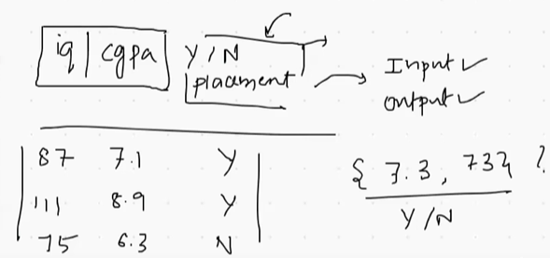

**The above consist of both input (IQ, CGPA) and the output (placement status). Now ML will do the prediction and as in we take new input it would give us the output.**

**Sub categories in supervised learning:**

1. **Regression**

**Data are of two types.**

**1. Numerical- age, weight, marks**

**2. Categorical -gender, nation**

**In supervised machine learning, if the output data is of type numerical then it is Regression.**

**Example:**

**In the data given below, it consists both input and output, Also the output (package) is of numerical data.**

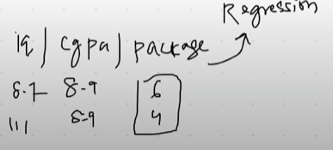

**Example: prediction of house price from various features.**

1. **Classification**

**In this type, output will be of categorical data as we have seen in the above supervised learning example.**

**Example: email spam classifier**

**2. Unsupervised Machine Learning**

**It consists only input not any output.**

**As the example mentioned for supervised ML, only IQ and CGPA would be given here in Unsupervised ML, from which we need to predict placement status.**

**Sub categories:**